*Imperial College of Engineering*

(RU Affiliated)

Lab Report

BSC Engineering 1st year 1st semester Examination,2024

Course title: Basic Electronics Lab

Course code: EEE 11 32

|  |  |
| --- | --- |
| **Submitted to:** | **Submitted by:** |
| **Shatu Karmokar** | **Name:Md.Rashidul Islam Zidan** |
| **Lecturer ,Department of EEE** | **Roll:23109** |
| **Imperial College of** | **Session:2023-24** |

Date: 18 /10 /2024

**INDEX**

|  |  |  |
| --- | --- | --- |
| **Lab NO** | **Content** | **Page** |
| **01** | **To study the I~V characteristics of a P-N junction diode.** | **3-8** |
| **02** | **To use PN junction diode as half-wave and full-wave rectifier** | **9-11** |
| **03** | **To study the input and output characteristics of a Transistor in CE configuration.** | **12-14** |
| **04** | **To study the characteristics of OP Amp in inverting and non inverting mode.** | **15-18** |
| **05** | **Verification of Ohm’s Law** | **19-21** |

I

Experiment No: 01

Name of the Experiment: To study the I~V characteristics of a P-N junction diode.

Objectives:

* To study the V-I characteristics of the PN junction diode
* Observe forward bias and reverse bias characteristics of the PN junction diode.

Apparatus:

1. Trainer Board (0-15V variable voltage supple)
2. Voltmeter 3. Connecting Wire

Theory:

Do you know how the PN-Junction was invented? Click here Invention StoryA semiconductor PN junction diode is a two-terminal electronic device (Di-electrode Diode.) that allows current in only one direction. The diode is formed by doping a semiconductor (like silicon or germanium) with a trivalent impurity (e.g. Boron or Aluminium) from one end to form a p-type region and with pentavalent impurity like Phosphorous from the other end to form an n-type region on the other end. The metal contacts taken out from the p-region and n-region are called anode and cathode respectively. There are three possible biasing conditions and two operating regions for the typical PN-Junction Diode, they are zero bias, forward bias, and reverse bias. When no voltage is applied across the PN junction diode then the electrons will diffuse to the P-side and holes will diffuse to the N-side through the junction and they combine. Therefore, the acceptor atom close to the P-type and donor atom near the N-side are left unutilized. An electronic field is generated by these charge carriers. This opposes further diffusion of charge carriers. Thus, the movement of the region is known as the depletion region or space charge.

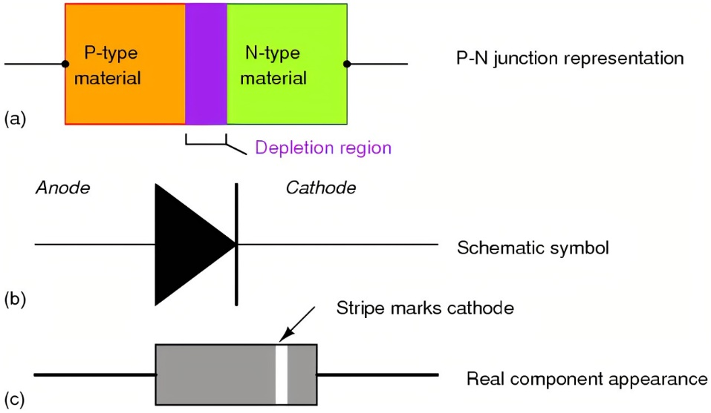

Fig-1: PN junction Diode

**Zero Biased PN Junction**: Diode When a diode is connected in a Zero Bias condition, no external potential energy is applied to the PN junction. The potential barrier that now exists discourages the diffusion of any more majority carriers across the junction. However, the potential barrier helps minority carriers (few free electrons in the P-region and few holes in the N-region) to drift across the junction. Then an Equilibrium or balance will be established when the majority carriers are equal and both moving in opposite directions, so that the net result is zero current flowing in the circuit. When this occurs the junction is said to be in a state of Dynamic Equilibrium.

The minority carriers are constantly generated due to thermal energy so this state of equilibrium can be broken by raising the temperature of the PN junction causing an increase in the generation of minority carriers, thereby resulting in an increase in leakage current but an electric current cannot flow since nocircuit has been connected to the PN junction.

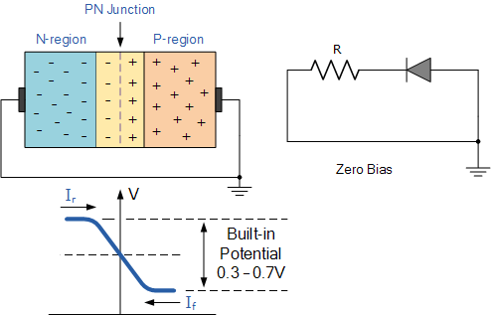

**Forward Biased PN Junction Diode**: When a diode is connected in a Forward Bias condition, a negative voltage is applied to the N-type material and a positive voltage is applied to the P-type material. If this external voltage becomes greater than the value of the potential barrier, approx. 0.7 volts for silicon and 0.3 volts for germanium, the potential barriers opposition will be overcome and current will start to flow. This is because the negative voltage pushes or repels electrons towards the junction giving them the energy to cross over and combine with the holes being pushed in the opposite direction towards the junction by the positive voltage. This results in a characteristics curve of zero current flowing up to this voltage point, called the knee on the static curves and then a high current flow through the diode with little increase in the external voltage as shown below.

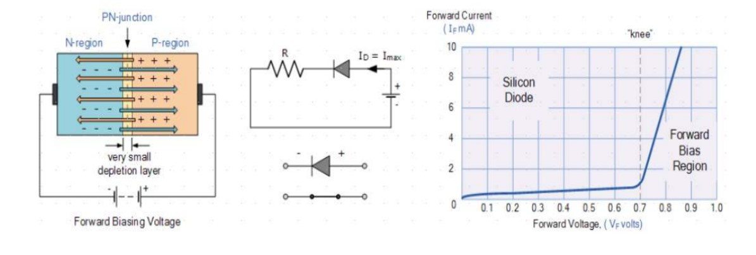

Since the diode can conduct infinite current above this knee point as it effectively becomes a short circuit, therefore resistors are used in series with the diode to limit its current flow. Exceeding its maximum forward current specification causes the device to dissipate more power in the form of heat than it was designed for resulting in a very quick failure of the device.

**Reverse Biased PN Junction Diode**: When a diode is connected in a Reverse Bias condition, a positive voltage is applied to the N-type mate-rial and a negative voltage is applied to the P-type material. The positive voltage applied to the N-type material attracts electrons towards the positive electrode and away from the junction, while the holes in the P-type end are also attracted away from the junction towards the negative electrode. The net result is that the depletion layer grows wider due to a lack of electrons and forms a potential barrier which prevent the current from flowing through the semiconductor material.

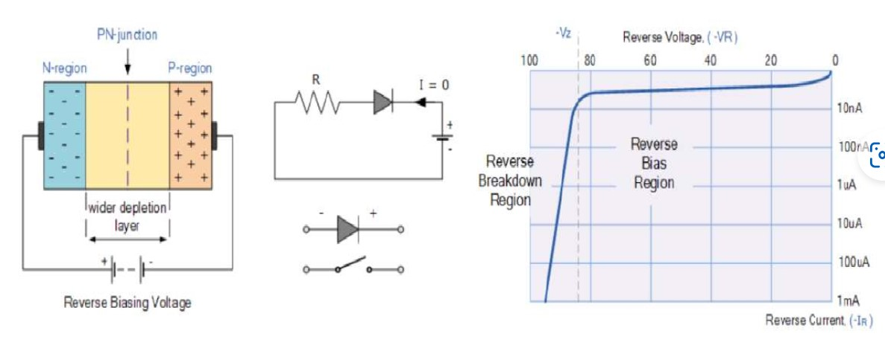

This condition represents a high resistance value to the PN junction and practically zero current flows through the junction diode with an increase in bias voltage. However, a very small leakage current does flow through the junction which can be measured in micro-amperes. One final point, if the reverse bias voltage $V_{r}$ applied to the diode is increased to a sufficiently high enough value, it will cause the diodes PN junction to overheat and fail due to the avalanche effect around the junction. This may cause the diode to become shorted and will result in the flow of maximum circuit current, and this shown as a step downward slope in the reverse static characteristics curve. Sometimes this avalanche effect has practical applications in voltage stabilizing circuits where a series limiting resistor is used with the diode to limit this reverse breakdown current to a preset maximum value thereby producing a fixed voltage output across the diode. These types of diodes are commonly known as Zener Diodes and are discussed in next experiment.

Circuit Diagram:

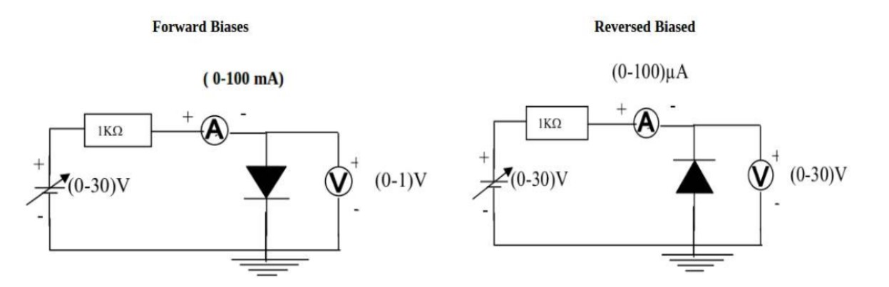

**Procedure:**

**FORWARD BIAS**:

1. Connect the circuit as per the diagram.

2. Vary the applied voltage V in steps of 0.1V.

3. Note down the corresponding Ammeter readings .

4. Plot a graph between $V_{F}$ and

**REVERSE BIAS**:

1. Connect the circuit as per the diagram.

2. Vary the applied voltage $V_{R}$ in steps of 0.5V.

3. Note down the corresponding Ammeter readings .

4. Plot a graph between $V_{R}$ and $I_{R}$

**Observations:**

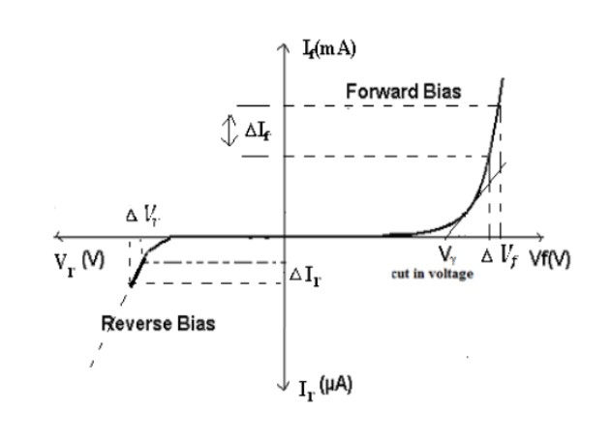

Least count of voltmeter = 0 V

Zero error of voltmeter = 0 V

Range of milli-ammeter = 2200 mA

Least count of milli-ammeter = 0.7 mA

Zero error of milli-ammeter = 0 mA

From the graph:

Static forward Resistance $R_{DC}$ = $\frac{V_{f}}{I_{f}}$ Ω

Dynamic forward Resistance $r_{ac}$ = $\frac{{∆V}_{f}}{{∆I}_{f}}$ Ω

Static Reverse Resistance $R_{DC}$ = $\frac{V_{r}}{I_{r}}$ Ω

Dynamic Reverse Resistance $r_{ac}$ = $\frac{V_{r}}{I_{r}}$ Ω

**Data Table:**

|  |  |  |
| --- | --- | --- |
| SI No | Voltage ( $V_{r})$ (in volts) | Current ($I_{r}$)  (In mA) |
| 01 | 00 | 00 |
| 02 | 02 | 00 |
| 03 | 05 | 00 |
| 04 | 07 | 00 |
| 05 | 09 | 00 |
| 06 | 12 | 00 |
| 07 | 15 | 00 |

Forward Bias Reverse Bias

|  |  |  |
| --- | --- | --- |
| SI No | Voltage ( $V_{f})$ (in volts) | Current ($I_{f}$)  (In mA) |
| 01 | 0.2 | 00 |
| 02 | 0.4 | 00 |
| 03 | 0.6 | 00 |
| 04 | 0.74 | 70 |
| 05 | 0.8 | 300 |
| 06 | 0.84 | 1500 |
| 07 | 0.9 | 2130 |

Result and Discussion:

If we increase voltage in forward bias ,when voltage is 0.2, the forward current will find 00 mA. When the voltage is 0.74 v ,it find 70 mA current in forward bias and it continuous increasing .

When we increase voltage in reverse bias ,it will not increase current . When the voltage is 00v, it is current 00 mA and it is voltage 15 v ,the reverse bise is 00 Ma. It does not increase reverse current.

Precautions and sources of error:

1. All connections should be neat, clean and tight.

2. Forward-bias voltage beyond breakdown should not be applied.

3. Reverse-bias voltage beyond breakdown should not be applied.

4. Connect voltmeter and Ammeter in correct polarities as shown in the circuit diagram.

5. Do not switch ON the power supply unless you have checked the circuit connections as per the circuit diagram.

Experiment No: 02

Name of The Experiment: To use PN junction diode as half-wave and full-wave rectifier

**OBJECTIVE**:

The basic objective of this lab

1. To know the basic uses of diode.

2. To know about Half wave and full wave rectification

3. To know about the characteristic of half wave rectifier circuit and full wave rectifier circuit.

4. To design a circuit using diode and other electronic circuit.

3. To know about the characteristic of half wave rectifier circuit and full wave rectifier circuit.

4. To design a circuit using diode and other electronic circuit.

**Apparatus**:

1. Transformer

2. Trainer board

3. Oscilloscope

4. Diode

**Theory:**

The main application of p-n junction diode is in rectification circuits. These circuits are used to describe the conversion of a.c signals to d.c in power supplies. Diode rectifier gives an alternating voltage which pulsates in accordance with time.

**Working of Half Wave Rectifier**

The half-wave rectifier has both positive and negative cycles. During the positive half of the input, the current will flow from positive to negative which will generate only a positive half cycle of the a.c supply. When a.c supply is applied to the transformer, the voltage will be decreasing at the secondary winding of the diode. All the variations in the a.c supply will reduce, and we will get the pulsating d.c voltage to the load resistor.

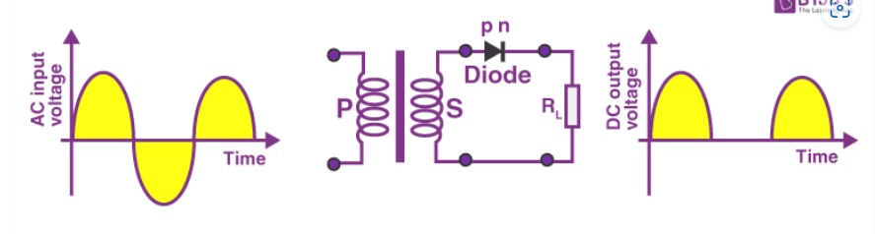

**What Is Full Wave Rectifier?**

Full-wave rectifier circuits are used for producing an output voltage or output current which is purely DC. The main advantage of a full-wave rectifier over half-wave rectifier is that such as the average output voltage is higher in full-wave rectifier, there is less ripple produced in full-wave rectifier when compared to the half-wave rectifier.

**Working of Full Wave Rectifier**

The full-wave rectifier utilizes both halves of each a.c input. When the p-n junction is forward biased, the diode offers low resistance and when it is reverse biased it gives high resistance. The circuit is designed in such a manner that in the first half cycle if the diode is forward biased then in the second half cycle it is reverse biased and so on.

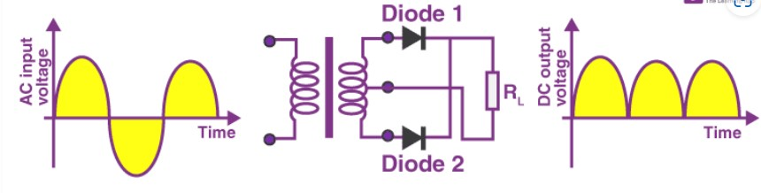

Circuit Diagram: Fig- Half wave rectifier

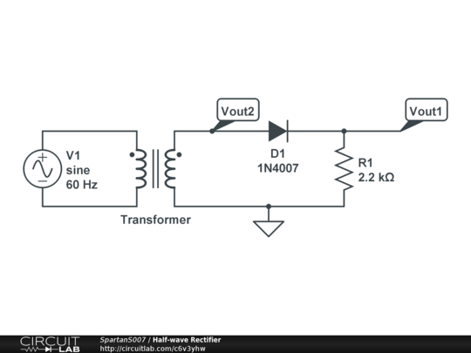

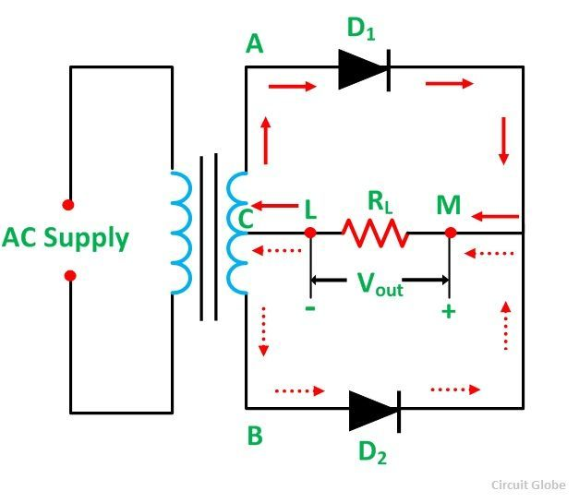

Fig: Full-wave Rectifier

|  |  |  |
| --- | --- | --- |
| SI No | Resistor | Output Voltage |
| 01 | 0 | 4.29 |
| 02 | 1k | 5.28 |
| 03 | 2k | 5.32 |
| 04 | 3k | 5.38 |
| 05 | 4k | 5.42 |
| 06 | 6k | 5.38 |

Data Table:

|  |  |  |
| --- | --- | --- |
| SI No. | Resistor | Output Voltage |
| 01 | 0 | 2.17 |
| 02 | 1k | 2.58 |
| 03 | 2k | 2.60 |
| 04 | 4k | 2.63 |
| 05 | 8k | 2.59 |
| 06 | 9k | 2.62 |

Result & Discussion:

In half wave rectification only, we get the output when the diode is forward biased, we get zero voltage at output when the diode is reversed biased it means we are throwing away the negative or blocked cycle of the waves. It means half wave is not so much effective in Ac to Dc conversion Vout=Vm-Vd. Vdc/ Average of the output voltage will be 0.318(Vm-Vd). Vm is input voltage amplitude and Vd is voltage drop across diode.

In full wave rectification we use bridge rectifier which consist of four diodes. For a positive cycle two diode operate and for the negative cycle the other two diode operate. These diodes help in converting the AC to pulsating DC. Full wave rectification is efficient because we are using both the cycle of input and get a positive cycle output for both positive and negative cycle. Vout=Vm-2Vd. Vdc/ Average of the output voltage will be 0.636(Vm-2Vd). 2Vd because two diodes are used and we have to minus them from input voltage Vm is input voltage amplitude and Vd is voltage drop across diod

Experiment No: 03

Name of The Experiment: To study the input and output characteristics of a Transistor in CE configuration.

Objectives:

* Observe the i/p and o/p characteristics of Transistor
* To know the working principle of a transistor

Equipment: 1. C828 IC 2. Resistor 2 pitch(2kohm) 3. Oscilloscope

1. Multimeter

Theory: Transistor IC



In common emitter configuration, base is the input terminal, collector is the output terminal and emitter is the common terminal for both input and output. That means the base terminal and common emitter terminal are known as input terminals whereas collector terminal and common emitter terminal are known as output terminals.

In common emitter configuration, the emitter terminal is grounded so the common emitter configuration is also known as grounded emitter configuration. Sometimes common emitter configuration is also referred to as CE configuration, common emitter amplifier, or CE amplifier. The common emitter (CE) configuration is the most widely used transistor configuration.

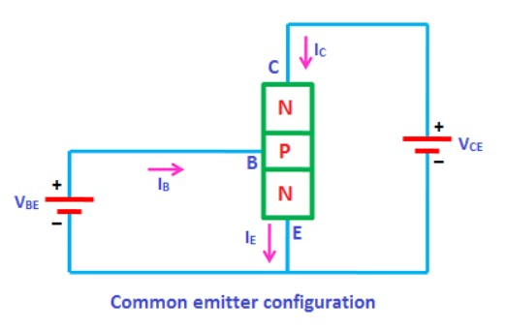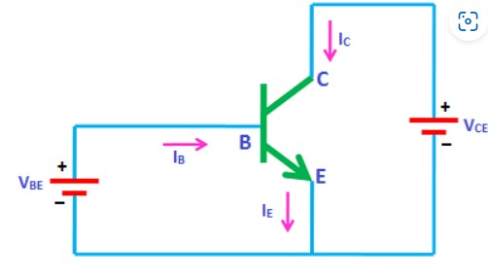

Fig: Common Emitter Configuration

Circuit Diagram:

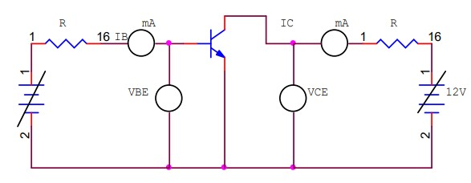

Fig: Circuit diagram of Common Emitter Configuration oof Transistor

Procedure:

Connect the circuit as per the circuit diagram

Input characteristics:

1. Keep emitter collector voltage constant.
2. Vary emitter-base voltage in steps and note down base current reading.
3. Readings are tabulated and graph is drawn

Output characteristics:

1. Keep base current constant.
2. Vary collector-emitter voltage in steps and note down emitter current.
3. Readings are tabulated and graph is drawn.

Data Table:

|  |  |  |  |  |
| --- | --- | --- | --- | --- |
| SI No. | Input characteristics  ( $V_{ce}$ const.) | | Output characteristics  ( $I_{b}$ const.) | |
| $V_{be}$ (volts) | $I_{b}$ (mA) | $V_{ce}$ (volts) | $I_{c}$ (mA) |
| 1. | 0.52 | 0.01 | 0.5 | 0.002 |
| 2. | 0.54 | 0.07 | 0.8 | 5.2 |
| 3. | 0.56 | 0.16 | 3.4 | 10 |
| 4 | 0.57 | 0.20 | 15 | 13.45 |

Graph:

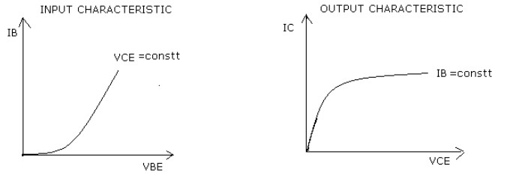

Result & Discussion:

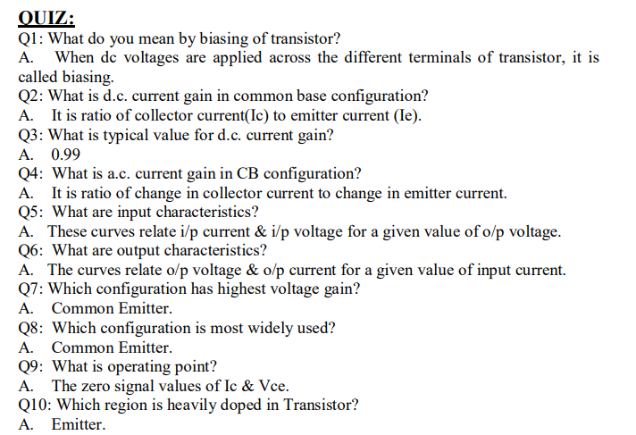The input output characteristic of transistor in common emitter configuration has been plotted

Experiment No: 04

Name of the Experiment: To study the characteristics of OP Amp in inverting and non-inverting mode.

Objectives:

* Design and realize Inverting and Non-inverting amplifier using 741 Op-amp.

Apparatus Required: Oscilloscope, Function generator, Bread board, 741 IC , ±12v power supply, Resistor 1kΩ, 10kΩ, connecting wire.

IC Diagram:

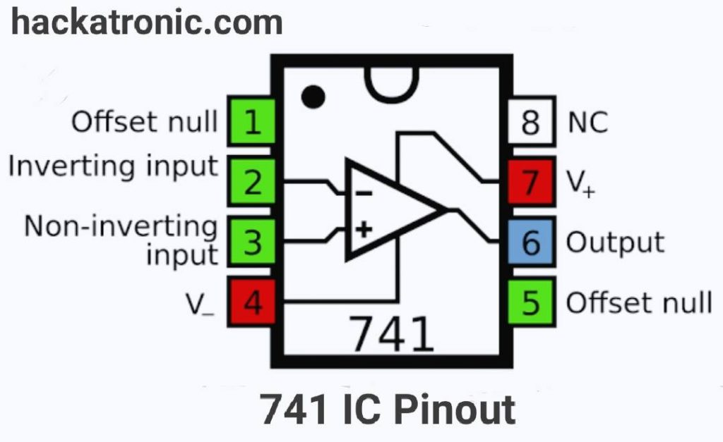

Theory:

An inverting amplifier using opamp is a type of amplifier using opamp where the output waveform will be phase opposite to the input waveform. The input waveform will be amplifier by the factor Av (voltage gain of the amplifier) in magnitude and its phase will be inverted. In the inverting amplifier circuit the signal to be amplified is applied to the inverting input of the op-amp through the input resistance R1. Rf is the feedback resistor. Rf and Rin together determine the gain of the amplifier. Inverting operational amplifier gain can be expressed using the equation Av = – Rf/R1. Negative sign implies that the output signal is negated. The circuit diagram of a basic inverting amplifier using op-amp is shown below.

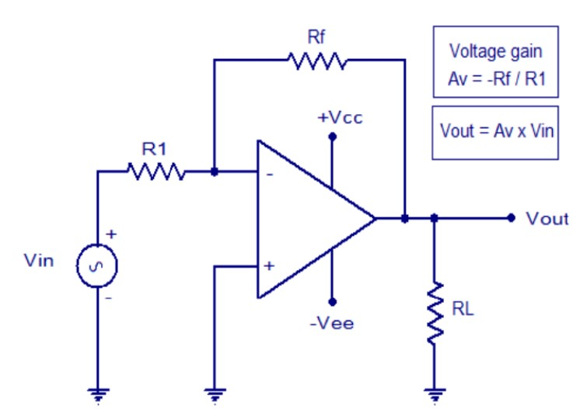

Fig: Op-amp Inverting Amplifier

The input and output waveforms of an inverting amplifier using op-amp is shown below. The graph is drawn assuming that the gain (Av) of the amplifier is 2 and the input signal is a sine wave. It is clear from the graph that the output is twice in magnitude when compared to the input (Vout = Av x Vin) and phase opposite to the input.

**Practical inverting amplifier using 741.**

A simple practical inverting amplifier using 741 IC is shown below. uA 741 is a high performance and of course the most popular operational amplifier. It can be used in a verity of applications like integrator.

Circuit Diagram:

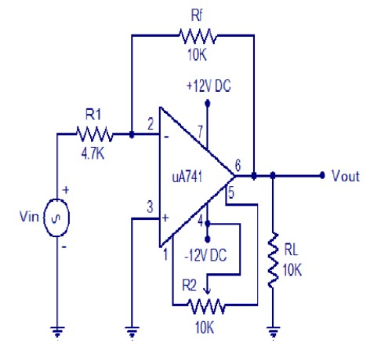

In the inverting amplifier only one input is applied and that is to the inverting input (V2) terminal. The Non inverting input terminal (V1) is grounded. Since, V1=0 V& V2=Vin Vo= -A Vin The negative sign indicates the output voltage is 1800 out of phase with respect to the input and amplified by gain A.

**Practical Non-inverting amplifier using 741:**

The input is applied to the non-inverting input terminal and the Inverting terminal is connected to the ground.

V1= Vin & V2=0 Volts

Vo= A Vin

The output voltage is larger than the input voltage by gain A & is in phase with the input signal.

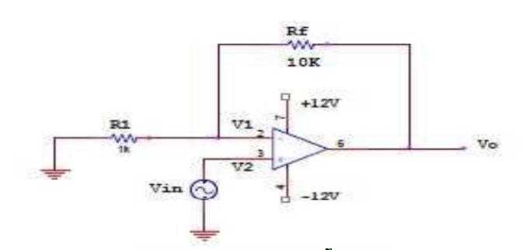

Fig: Circuit Diagram of Non-Inverting amplifier

Procedure:

1) Connect the circuit for inverting, non-inverting amplifier on a breadboard.

2) Connect the input terminal of the op-amp to function generator and output terminal to CRO.

3) Feed input from function generator and observe the output on CRO.

4) Draw the input and output waveforms on graph paper.

Output waveform:

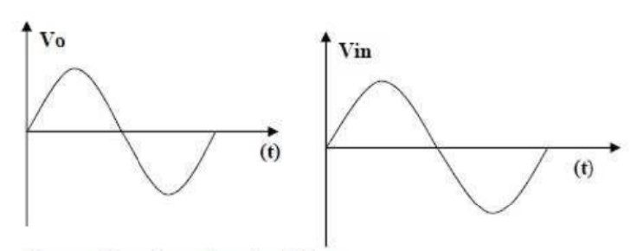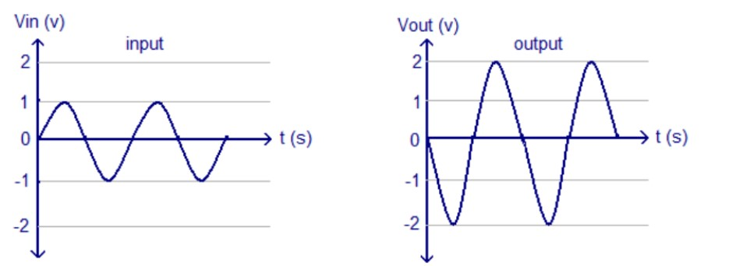

Fig: Output of Non-inverting and Inverting amplifier

Data Table:

|  |  |  |  |  |
| --- | --- | --- | --- | --- |
| SI No | Non Inverting Amplifier | | Inverting Amplifier | |
| Vin | Vo | Vin | Vo |
| 1 | 3 | 9 | 5v | -12.78v |

Result & Discussion:

Hence verified and drawn the operation and respective waveforms of inverting and non-inverting amplifier.

Experiment No: 05

Name of the experiment: Verification of Ohm’s Law

Objective:

a. To study about Ohm’s Law

b. To prove Ohm’s Law

c. To verify Ohm’s Law using experimental results

THEORY:

Ohm’s law describes mathematically how voltage ‘V’, current ’I’ and resistance ‘R’ in a circuit are related. According to this law: “The current in a circuit is directly proportional to the applied voltage and inversely proportional to the circuit resistance”. Ohm’s law is among the most fundamental relationships in electrical engineering. It relates the current, voltage, and resistance for a circuit element so that if we know two of the three quantities, we can determine the third. Thus, if we measure the current flowing in a resistor of known value, we can deduce the voltage across the resistance according to V = IR. Similarly, if we measure the voltage across a resistor and the current through it, we calculate the resistance of the element to be R = V/I. Not only does this reduce the number of measurements that must be made, it also provides a way to check the results of several different measurement methods.

FORMULA:

For a constant value of Temperature, V is directly proportional to I

i.e. V 𝛼 I,

which indicates, V = IR

Equipments

• Variable DC power supply -1 piece

• Digital multimeter (DMM) -1 piece.

• Resistance

• Connecting Wires.

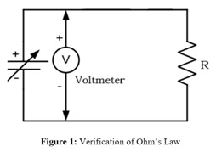Circuit Diagram:

PROCEDURES: Before Turning ON power supply, verify your circuit

1. Measure the value of the Resistance R and input the value in Data Table.

2. Construct the circuit of Figure 1.

3. Turn on the power supply and adjust it to voltage level as instructed in Data Table.

4. Input the values of voltage level in the Data Table.

5. Increase the values of voltage as shown in the Table 1. Measure the current I in turn and

record the values in Table 1.

6. Calculate the values of current I by using I=V/RT. Use measured values of resistances.

Data Table:

|  |  |  |  |
| --- | --- | --- | --- |
| SI NO | Resistance | Voltage (v) | Current I (mA |
| 01 | 1k | 0.0 | 0.00 |
| 02 | 1k | 1.0 | 0.83 |
| 03 | 1k | 1.5 | 1.25 |
| 04 | 1k | 2.0 | 1.67 |
| 05 | 1k | 2.5 | 2.08 |
| 06 | 1k | 3.0 | 2.50 |
| 07 | 1k | 3.5 | 2.91 |

Result & Discussion:

The Ohm’s Law is verified through the experiment.